Huarui Yao
Dr. Richard H. Hartwell
MSSP 607-001
29 September 2026
Academic Performance Analysis of Engineering Students
Executive Summary
This report examines how students’ backgrounds are related to differences in academic performance using the Data of Academic Performance Evolution for Engineering Students dataset (De La Hoz). The report focuses on three main factors: parental education, socioeconomic stratum, and gender. S11 average scores and Global Assessment scores are used to compare student performance across these groups, with visualizations and descriptive measures showing both the patterns and the size of the differences. The analysis also considers whether these patterns are consistent and how strongly the data support the observed relationships. Additional exploratory analyses were conducted in the Colab Notebook to provide further context for the main findings and their limitations.
Introduction
Differences in academic performance may come from more than what happens in the classroom. Students have different family backgrounds, socioeconomic conditions, and personal characteristics, but these factors may not be equally related to their academic outcomes. This report focuses on three questions: how parents’ education is related to student performance, how performance differs across socioeconomic strata, and whether gender differences appear in the Global Assessment. Rather than simply looking at which groups score higher, I also examine how large these differences are and whether the patterns are consistent. Additional analyses in my Colab Notebook are used to explore other patterns and better understand the limitations of these findings.
Body
Parental Education
The first analysis examines the relationship between parents’ education levels and students’ academic performance. The boxplots first compare the distribution of students’ S11 average scores across different education levels of fathers and mothers. In both comparisons, students whose parents have postgraduate education show the highest overall performance, with higher median S11 scores than students in the other parental education categories.
A similar pattern appears when the outcome is changed from S11 performance to the later global assessment score (G_SC). Again, students whose fathers or mothers have postgraduate education show the highest overall performance. The consistency of this pattern across both S11 and G_SC suggests that parental education is positively associated with students’ academic outcomes.
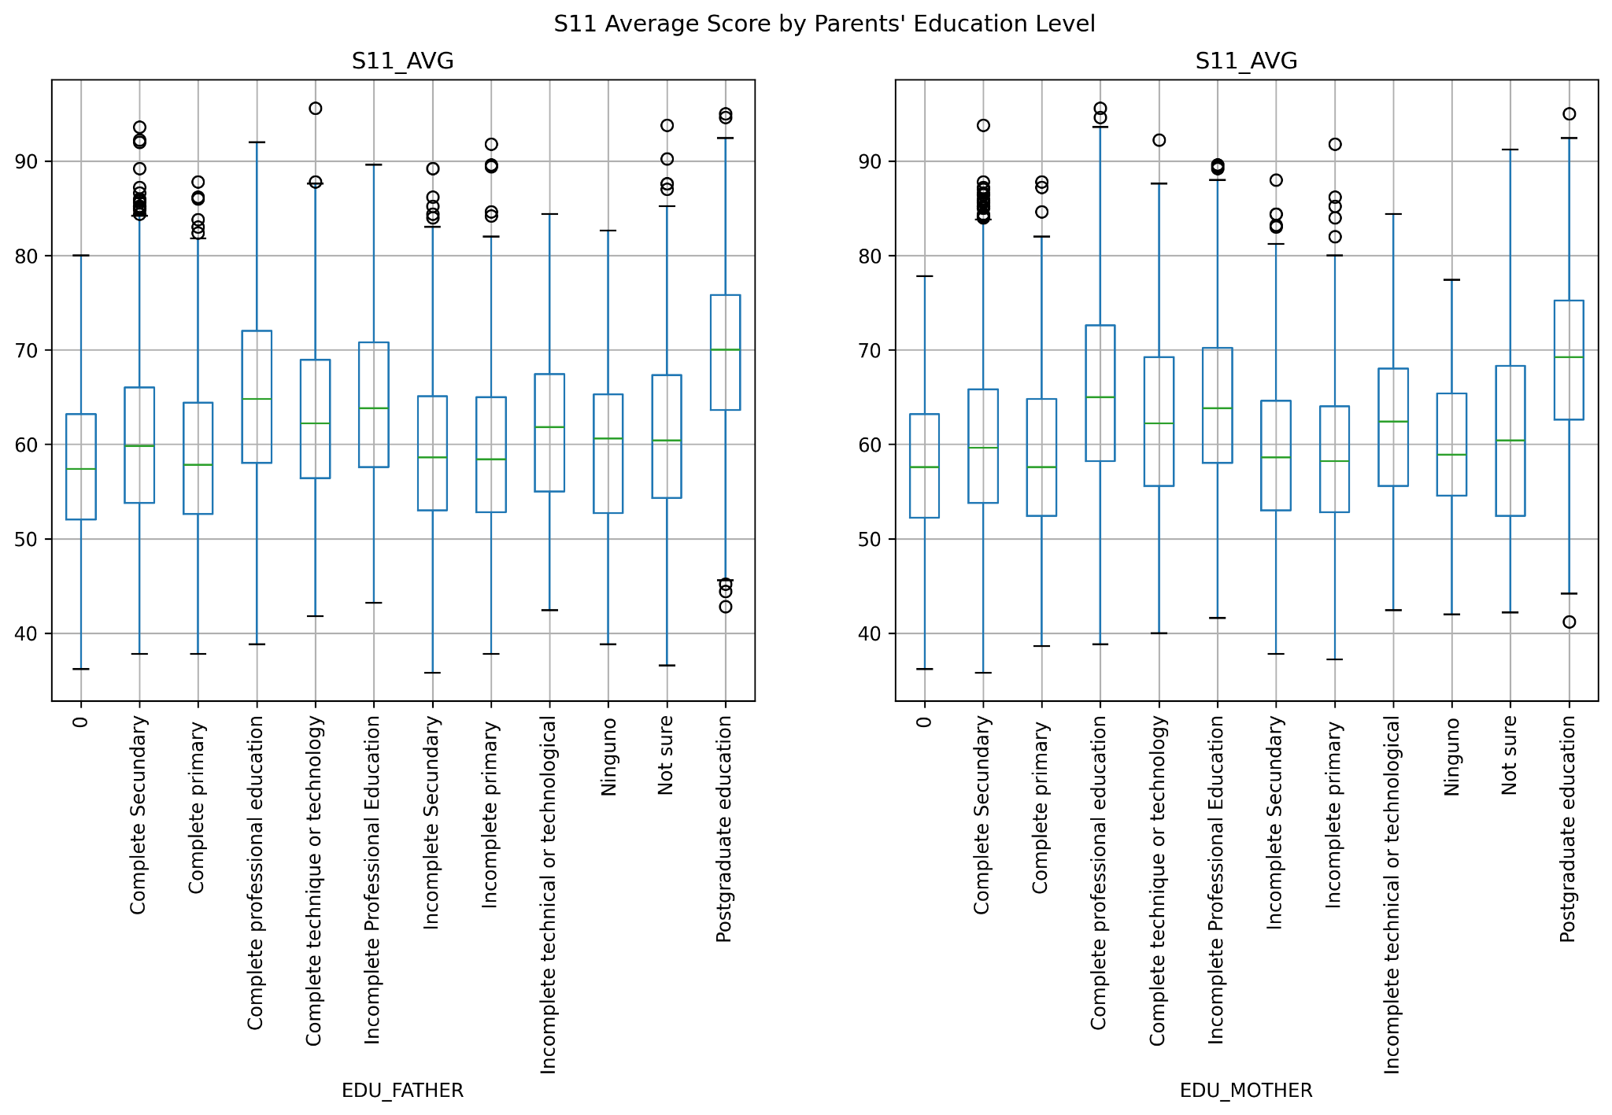
Fig 1. S11 Average Score by Parents’ Education Level
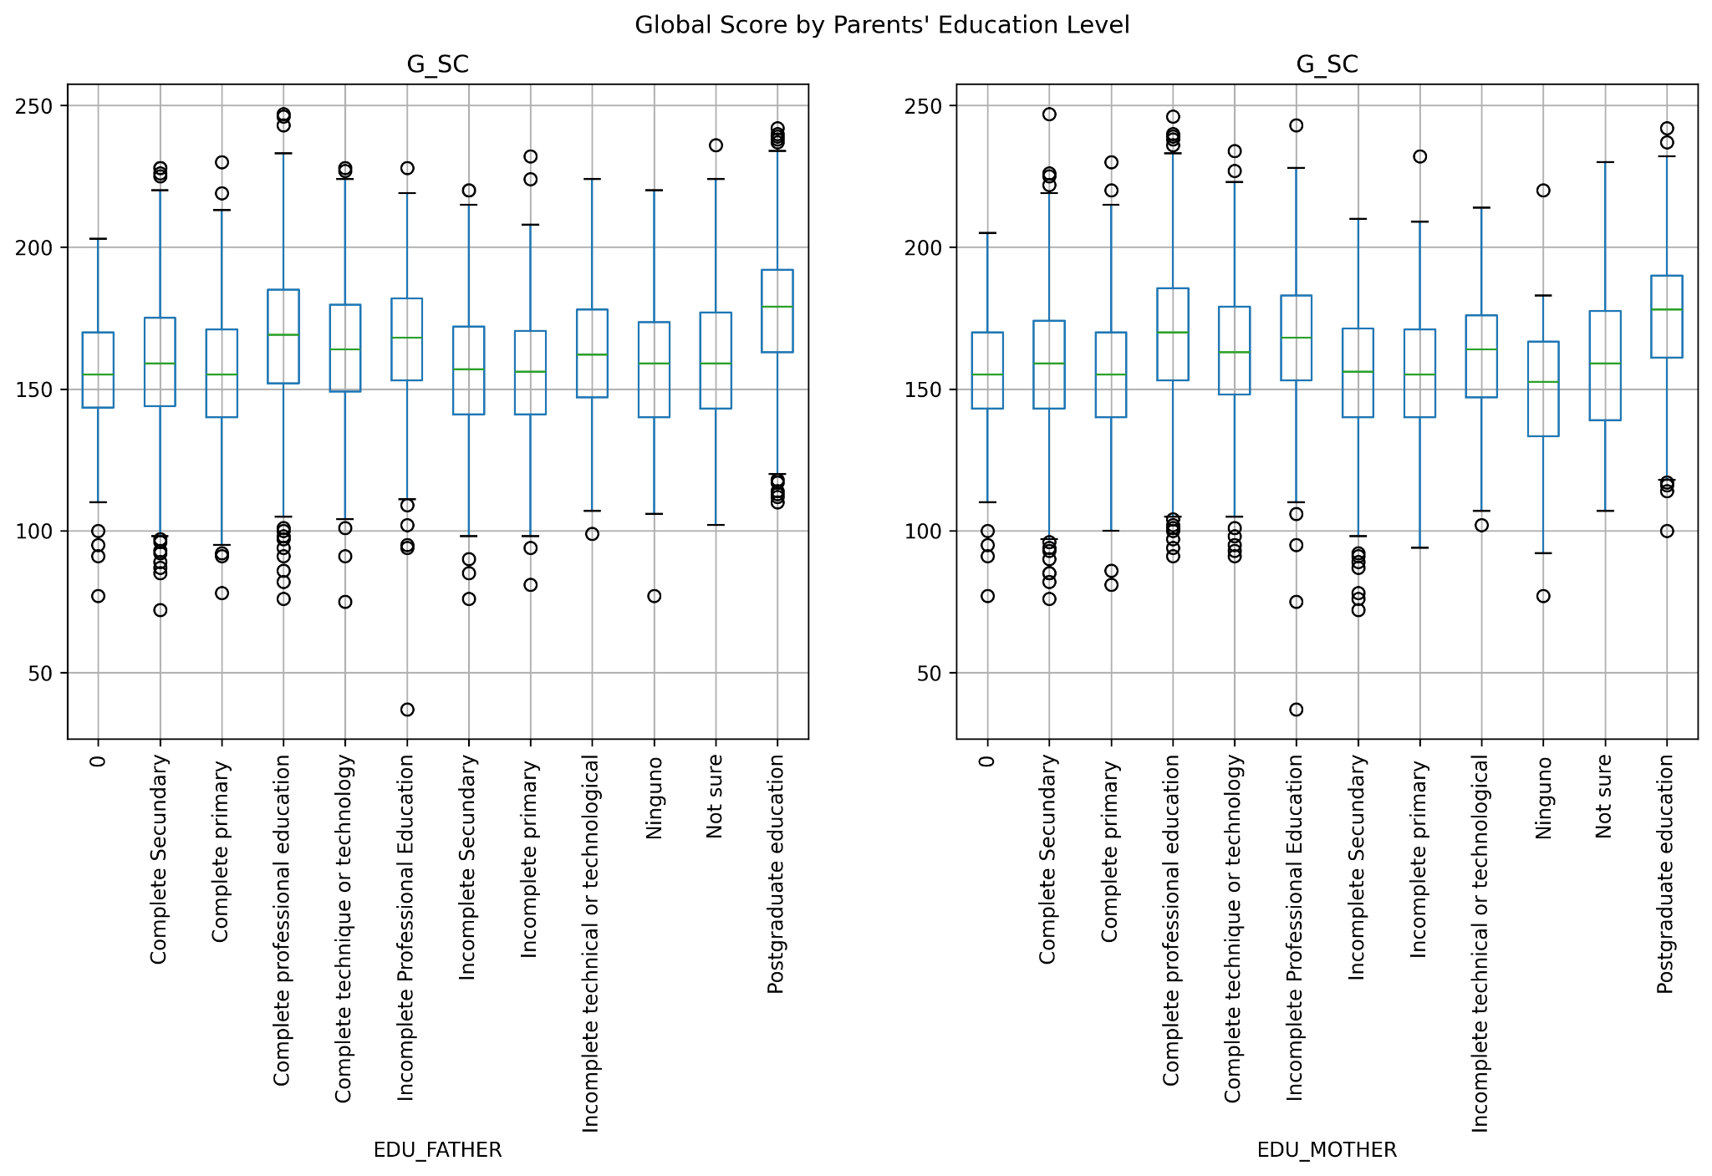
Fig 2. Global Score by Parents’ Education Level
To further examine the magnitude of these differences, I calculated the mean student performance for each parental education category. I then compared the highest and lowest group means using the percentage difference relative to the lowest mean. For S11 performance, the difference is 20.39% across fathers’ education categories and 18.62% across mothers’ education categories. Averaging these two values gives an overall descriptive difference of approximately 19.50%. The same calculation was applied to G_SC. The percentage difference between the highest- and lowest-performing groups is 14.13% for fathers’ education and 17.32% for mothers’ education, producing an average of approximately 15.72%. Overall, the results suggest that parental education is associated with meaningful differences in student performance at both stages.
Overall, the results suggest that parental education is related to student performance, although the pattern is not consistent across all education levels. The observed difference is somewhat larger for S11 performance than for G_SC.
Socioeconomic Stratum
The second analysis examines differences in academic performance across socioeconomic strata. I calculated the mean S11_AVG and G_SC for each stratum and used line plots to compare their patterns. As shown in Figure 3, from Stratum 1 to Stratum 6, both S11_AVG and G_SC show a clear upward trend. The mean S11_AVG increases from 57.57 to 72.48, while G_SC increases from 152.35 to 181.51. Stratum 6 performs the best on both measures. Overall, the results show clear differences across socioeconomic strata, with students in higher strata generally achieving better academic performance.
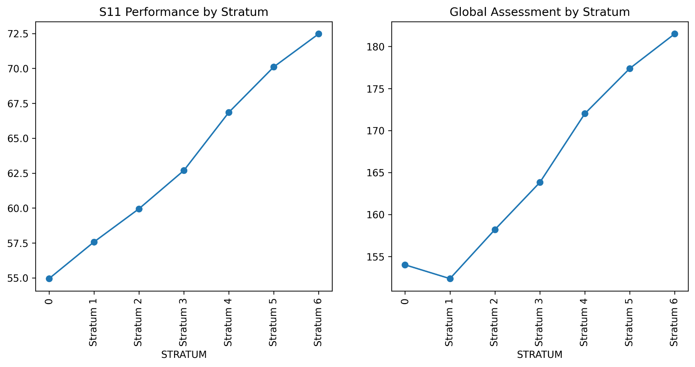
Fig. 3. Academic Performance by Socioeconomic Stratum.
Global Assessment by Gender
The final analysis examines whether students’ global assessment performance differs by gender. The dataset includes 7,368 male students and 5,043 female students. As shown in Figure 4, male students have a slightly higher average G_SC score of 163.69, compared with 161.28 for female students. However, the difference is only 2.41 points, suggesting that the performance gap between the two groups is relatively small. This result is important from a decision-making perspective. Although gender is associated with a small difference in average performance, the descriptive results do not show a large gender gap. Therefore, gender alone may not be a strong basis for identifying which students need additional academic support, and other factors may be more useful when explaining differences in student performance.
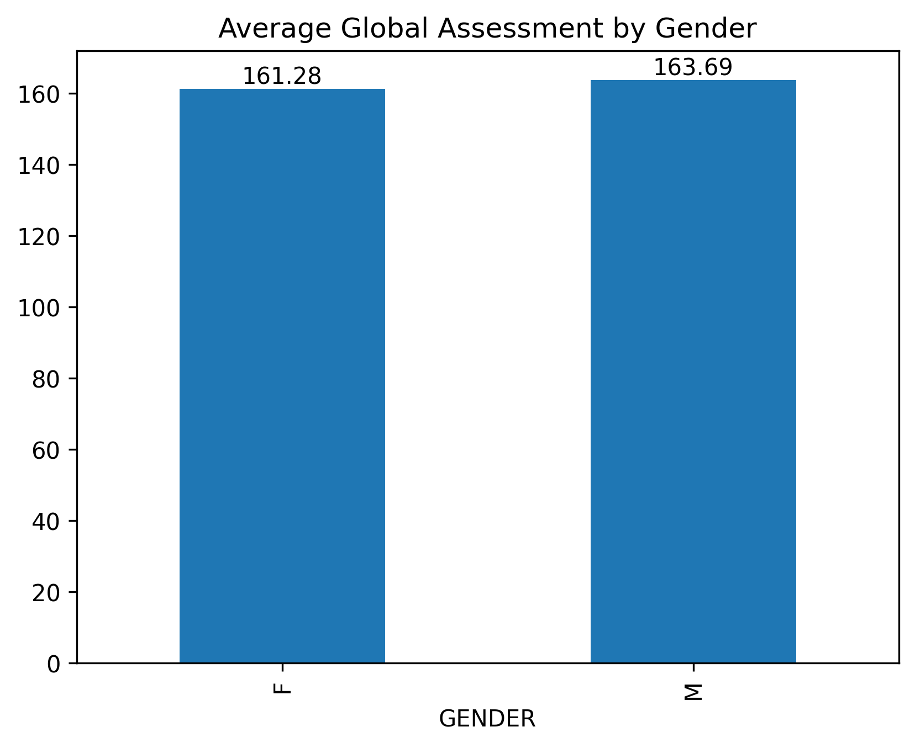
Fig. 4. Average Global Assessment by Gender.
Additional Findings and Limitations
Beyond the three main questions, I also explored additional relationships in my Colab Notebook, including correlations across S11 subjects, the relationship between S11 and later global assessment performance, and Internet access. Looking at all of these results together, what stood out to me is that finding a relationship does not necessarily mean that the relationship is strong. Some patterns are much clearer than others. Socioeconomic stratum provides the clearest example: student performance rises steadily as stratum increases. Parental education, however, tells a less consistent story. Although students with postgraduate parents perform the best, the other education groups overlap considerably and do not show the same steady increase. My percentage calculation also compares only the highest and lowest group means, leaving out the categories in between, which may make this relationship appear stronger than the full distribution suggests. A similar issue appears with gender: male students have a slightly higher average G_SC, but the gap is too small to provide strong evidence of a meaningful difference in academic performance. Internet access also appears to be related to performance, but this relationship may partly reflect differences in socioeconomic status.
Conclusion
Overall, the most interesting finding from this analysis is that not every background factor shows the same level of difference or consistency. Looking at all of the results together, I found that student performance cannot be easily explained by a single background factor. Socioeconomic stratum shows a relatively clear pattern, while parental education and gender provide much weaker evidence than I initially expected. The additional analyses in Colab also show that academic performance is related across subjects and over time, and that access to resources may be another factor worth considering. For me, the main takeaway is that differences in student performance seem to come from multiple factors rather than one simple explanation, and some relationships that appear important at first become much less clear when the data are examined more closely.

Works Cited
De La Hoz, Enrique. “Data of Academic Performance Evolution for Engineering Students.” Mendeley Data, version 1, 2020, https://doi.org/10.17632/83tcx8psxv.1.

